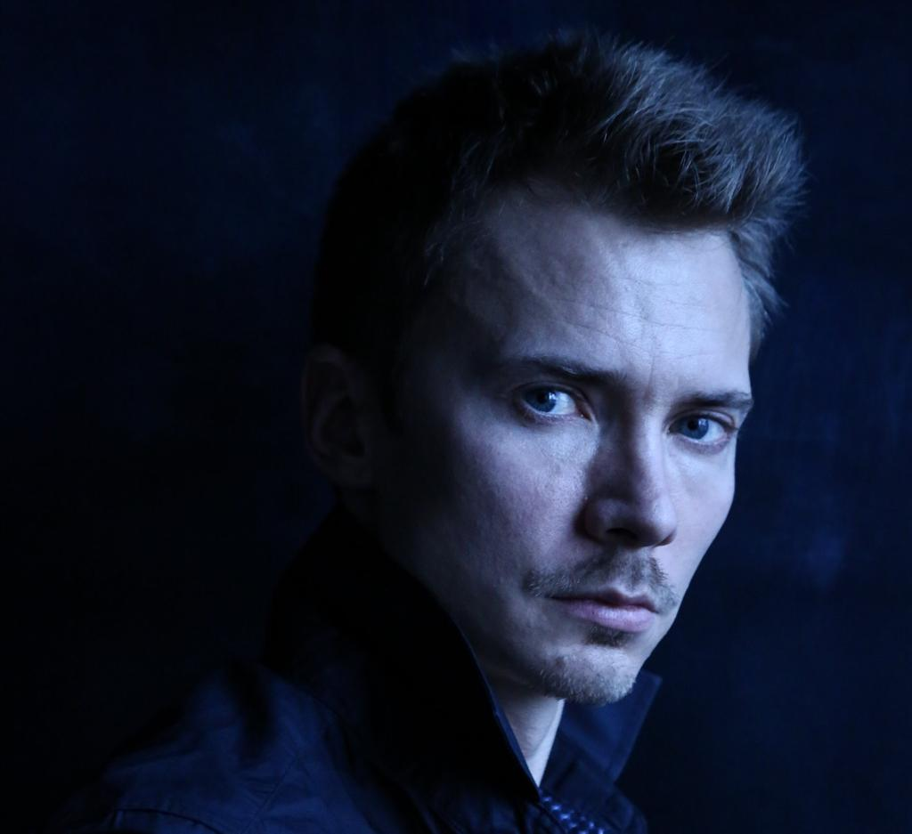

Kirill Radev
Kirill Radev was born in 1981 in Russia.
In 1991 began his dance training at the Russian Ballet Academy of A.Vaganova.
He joined Imperial Russian Ballet in 1999 as a soloist, rising to the rank of principal dancer in 2003.
In 2008, Radev joined (Corella Ballet) Barcelona Ballet as a Soloist, with Angel Corella as a director.
He finished the career at Moscow State Academy of Choreography getting the certificate as a choreographer, in 2010. Radev's awards include: The Grand Prix at the 7-th International Ballet Competition of Luxemburg in 2003, as a dancer. A Diploma of the 8-th Competition of Ballet Dancers of Russia open, for participation of foreign dancers, Perm in 2004, as a dancer. As a choreographer, the Bronze Medal at the VII Serge Lifar international Ballet Competition, Donetsk, Ukraine in 2011, finalist of Moscow International Ballet competition and Choreography contest 2017, first prize and audience prize of International Contemporary Dance Festival Contex – Diana Vishneva 2109.
Radev began his career as a choreographer in 2008. He has since created ranging from pas de deux to full one act ballet. In the list of his works are; «Suspiri» music by E. Elgar (performed in Russia) 2008; «Two» music by A.Vivaldi (performed in Russia) 2009; «Prelud» music by F.Chopin (performed in Russia, Bolshoy Theater) 2009; «Ave Maria» music by F.Shubert (performed in Italy by Angel Corella) 2009; «Simfonietta» music by B.Chaykovskiy (performed in Russia) 2010; «Autumn prayer» music by Y.Abdokov (performed in Russia, Spain) 2010; «Reflections» music by E.Grieg (performed in Ukraine) 2011; «Tocatta for two» music by S.Prokofiev (performed in Ukraine) 2011; «Rain is falling» music by E.L.O. (performed in Spain, Barcelona Ballet) 2011; «Strange magic» music by E.L.O. (performed in Spain, Barcena Ballet) 2011; «Звук и отзвук» music by E.Ysaye (performed in Russia, Bolshoy theater) 2013; «Sombras ajenas» music by Y.Abdokov (performed in Russia, Bolshoy theater and Barcelona Ballet, Spain) 2013; «Inhalation» music by S.Rachmaninov (performed in Russia) 2014.
In 2012, Kirill Radev created his second commissioned work for the Barcelona Ballet: «Facing the light» music by A.Vivaldi. This ballet was a remarkable success. The Barcelona Ballet included to the repertoire. In 2014 he made his third commissioned work for a russian ballet company named Ballet Moscow. This ballet was «Three poems» music by Y.Abdokov, included to the repertoire of the company.
In 2015, Radev was invited to College of Yakutsk. This is a superior ballet school, which asked him to creat one choreography for the final test of the senior students. He created «Dialogues». It was a total success.
​ After that, In April of 2016, created a piece for "Instituto del Teatre" of Barcelona named "Corelló" with music of J.Savall. It was performed by students of the later grades. The premiere of "MAJOR OR MINOR?", on May 29th, it was placed on the stage of The Bolshoi Theatre, Russia. Radev was invited to take part of the "Young Choreographers Workshop of The Bolshoi Theatre". After that, in October, it came out his colaboration with the dance company LaMov with their new production of "7 Pecados Capitales".
​ At 2017, Kirill Radev made his work in Russia. First of all, in St.-Petersburg, he created a modern opera named "Oedipus Rex". The premiere took place at the Aleksandrinskiy Theatre in February. The second work in his motherland was a ballet inspired by F. Kafka "Metamorphosis". The result was a one acte ballet for the company of Theatre New Ballet in Moscow.
Radev have been invited to take a part of Russian TV project «Bolshoy Ballet» 2018 as a choreographer to work with international rising ballet star Julian Mackay.
At 2019 he made his first independed project with his own agency «Creation Agency», ballet «Ballad for a Madman» where Radev is autor of idea and choreographer and the director of the company «KORPO Dance Project».

